**Automating Code Summarization with AI: A Step-by-Step Guide**

**Objective:**

This tool aims to streamline the process of summarizing large codebases from public repositories using AI tools like OpenAI. Instead of manually copying code to an AI platform, this solution allows you to run Python scripts to automatically fetch, summarize, and visualize the code with minimal intervention.

**Steps to Use the Tool**

**Step 1: Provide the Public Repository Link**

To begin the process, provide the public GitHub repository link from which the code will be fetched. This will be used by the first Python script to clone the repository and store the content.

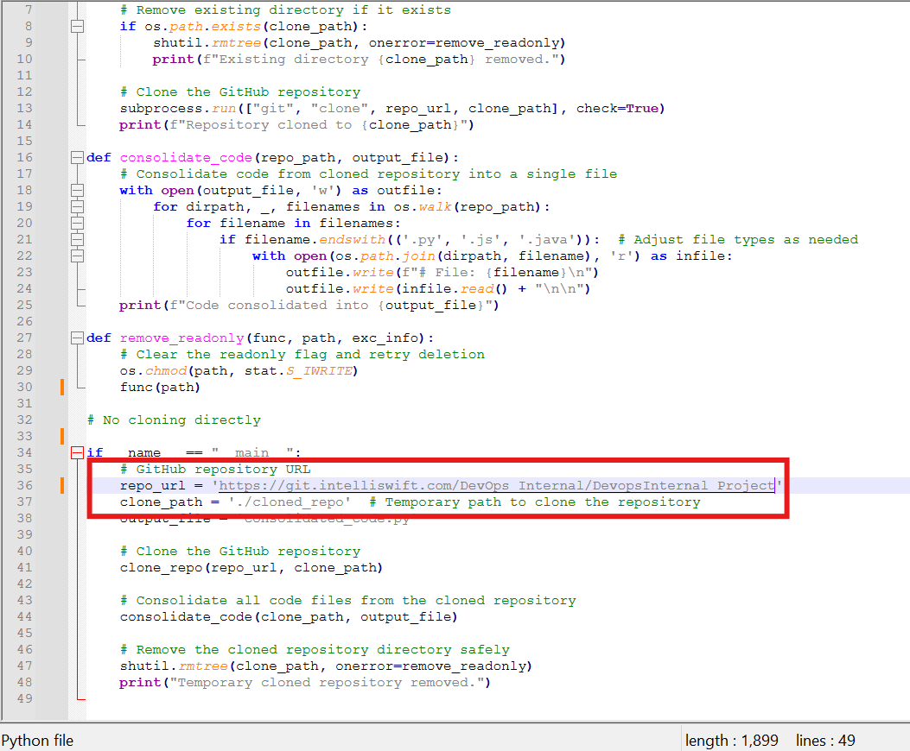

**Step 2: Clone the Repository and Consolidate Code**

1. **Run the Python Script:**python consolidate.py
2. **What Happens Next:**

The script will clone the provided repository and combine all the source code files into a single Python file named consolidated_code.py.

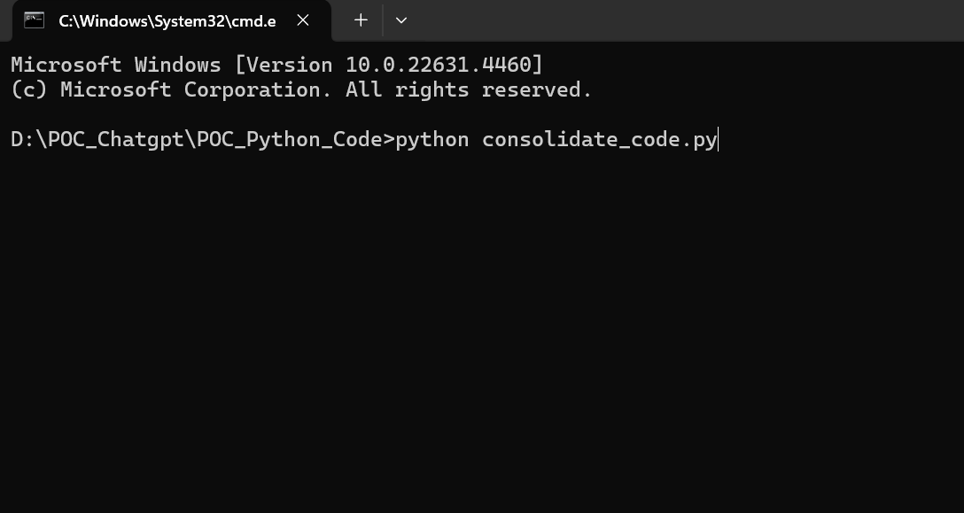

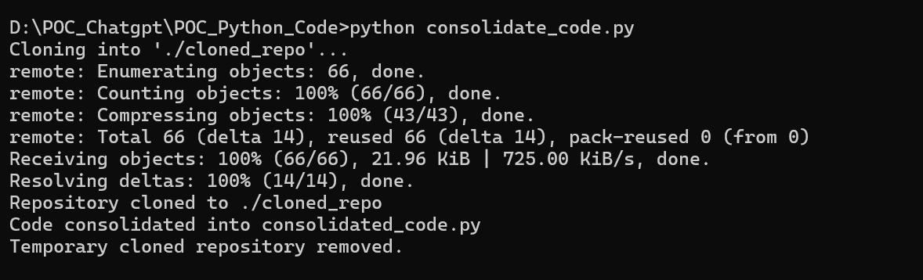

**Step 3: Send the Code to OpenAI for Summarization.**

1. **Run the Query Script:**

After the code is consolidated into consolidated_code.py, the next step is to send the code content to OpenAI for summarization.

**Run the Python script:**

python query_chatgpt.py

1. **Output:**

The script will take the content of consolidated_code.py, send it as a prompt to OpenAI, and store the summarized response in a file called line.txt.

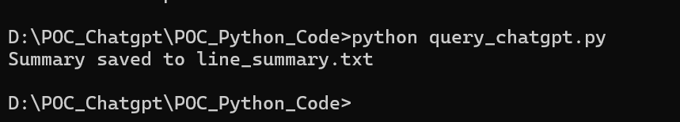

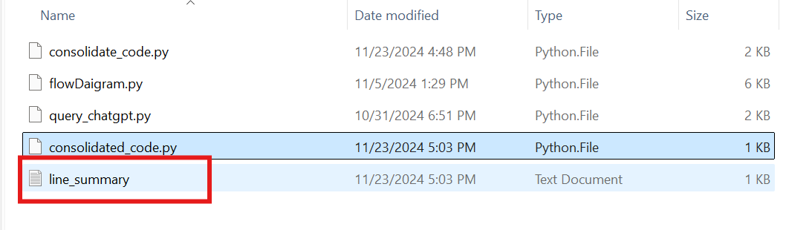

**Step 4: Visualize the Summary with a Flow Diagram**

Sometimes, the summary generated may still be difficult to understand. To make it easier, you can convert the textual summary into a flow diagram.

1. **Run the Flow Diagram Script:**

The following Python script will convert the content of line.txt into a flow diagram:

python generate_flow_diagram.py

1. **Output:**

This script will generate a flow diagram from the summary and save it as a PDF file, making the summary more accessible and visually understandable.

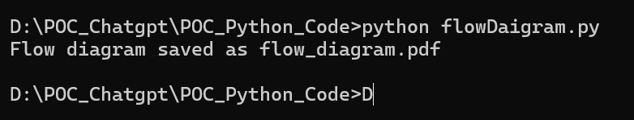

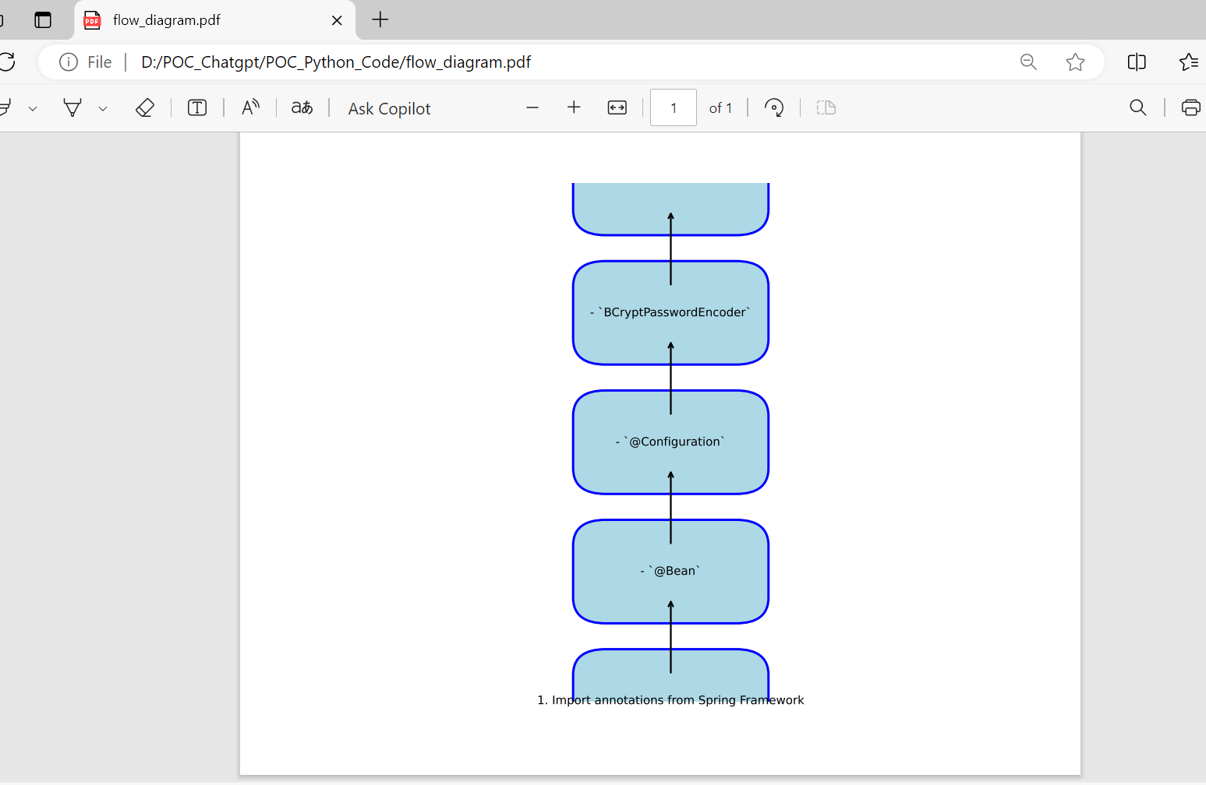

**Conclusion:**

1) This tool reduces the manual effort involved in reviewing and summarizing complex code, allowing developers to quickly grasp the structure and functionality of large projects. With this workflow, developers can spend more time focusing on improving the code, rather than understanding it.

2) By automating these processes, you save valuable time and gain a more efficient approach to working with code, all while making use of the latest AI technology to enhance your development workflow.